**Searching BFS DFS**

* **Graph + Tree Traversal:**

Traversal and search used interchangeably.

Traversal means visiting every node. O(n)

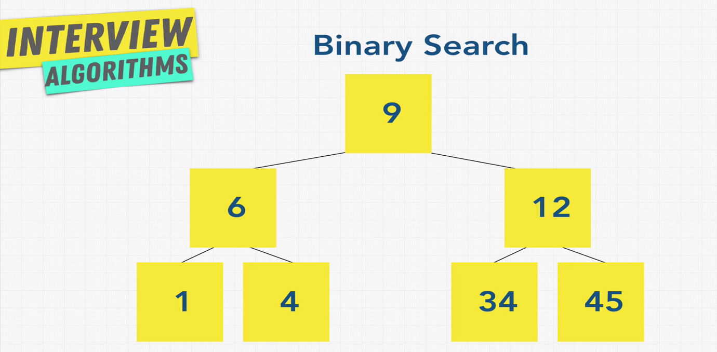

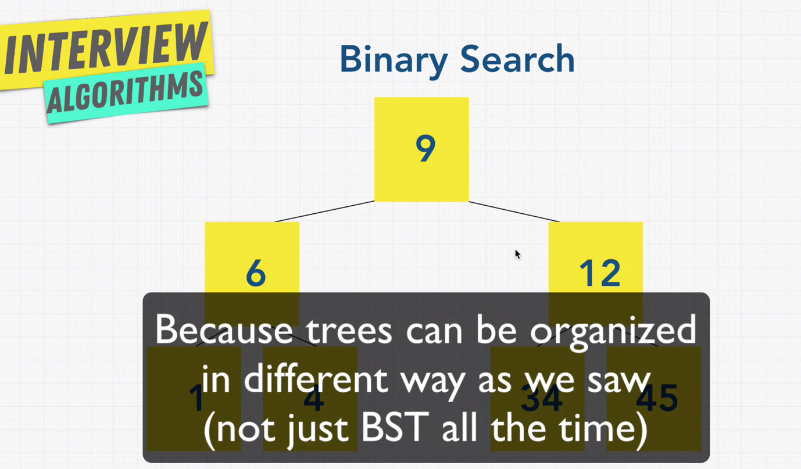

* **BFS Introduction:**

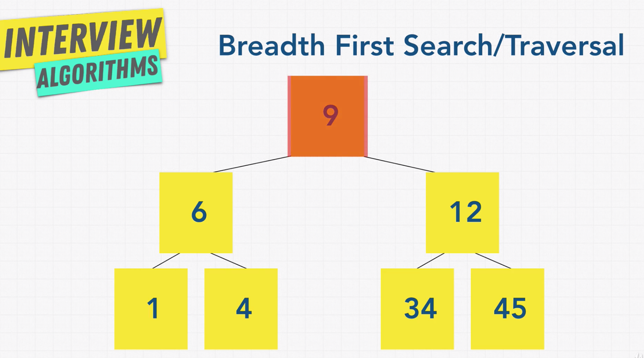

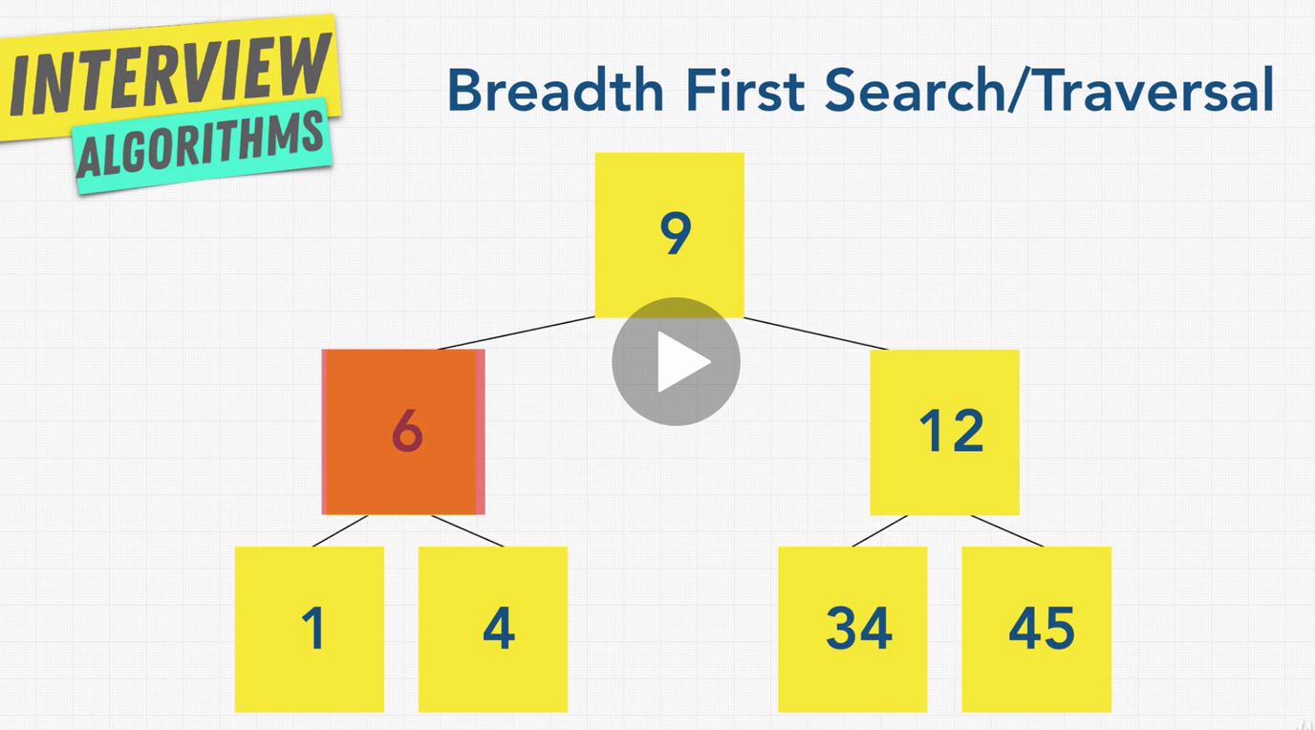

BFS -> Start from left and then navigate to right on each level.

You have to keep go, until you find what you are looking for or to end of the tree.

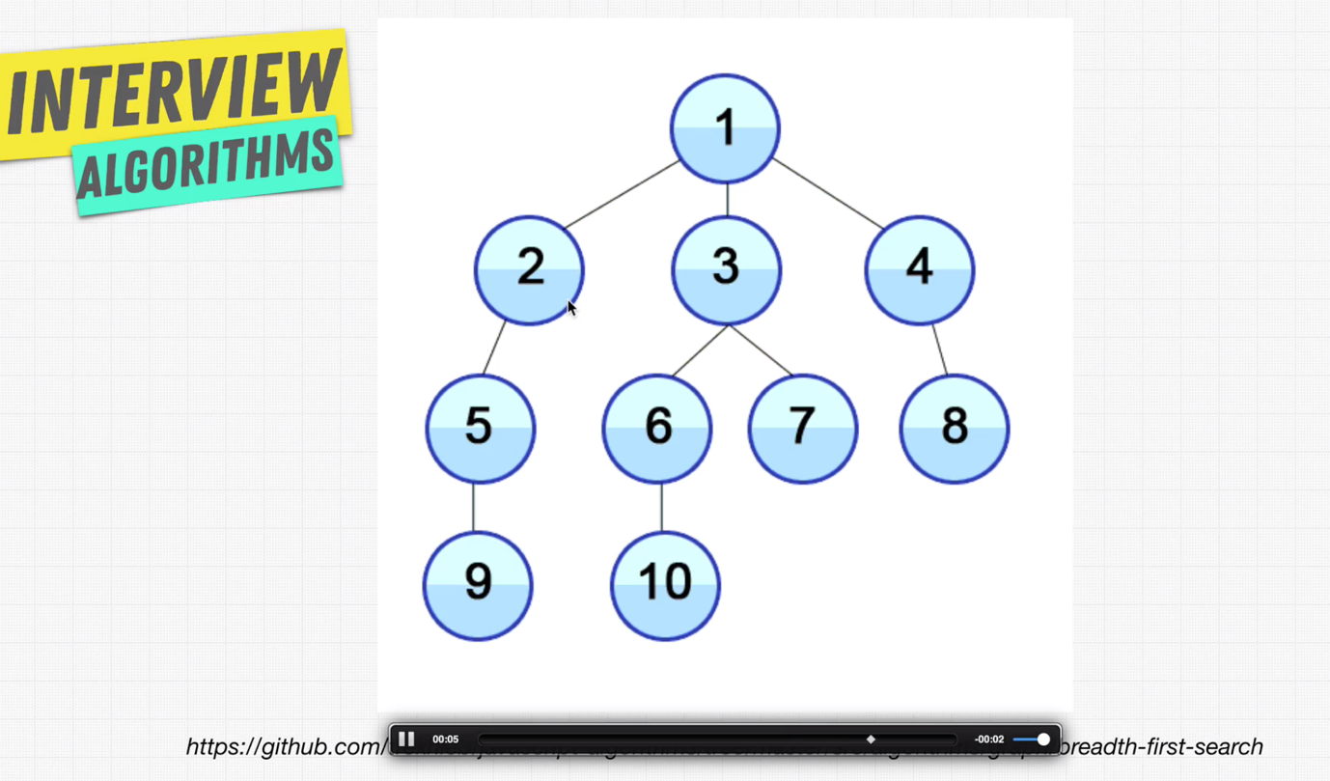

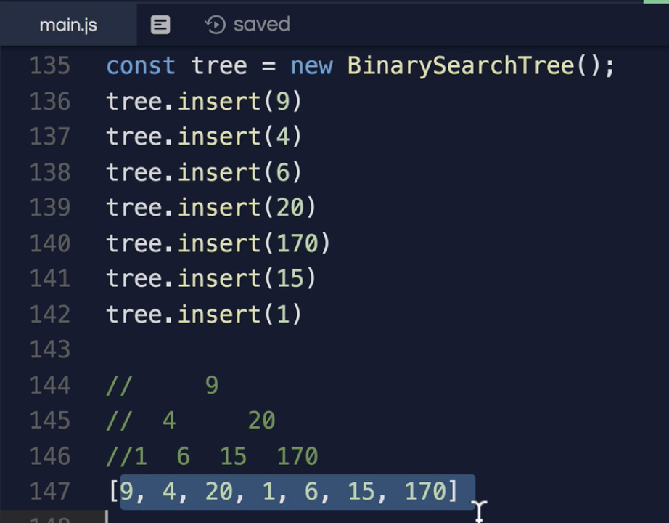

* **DFS (Depth First Search):**

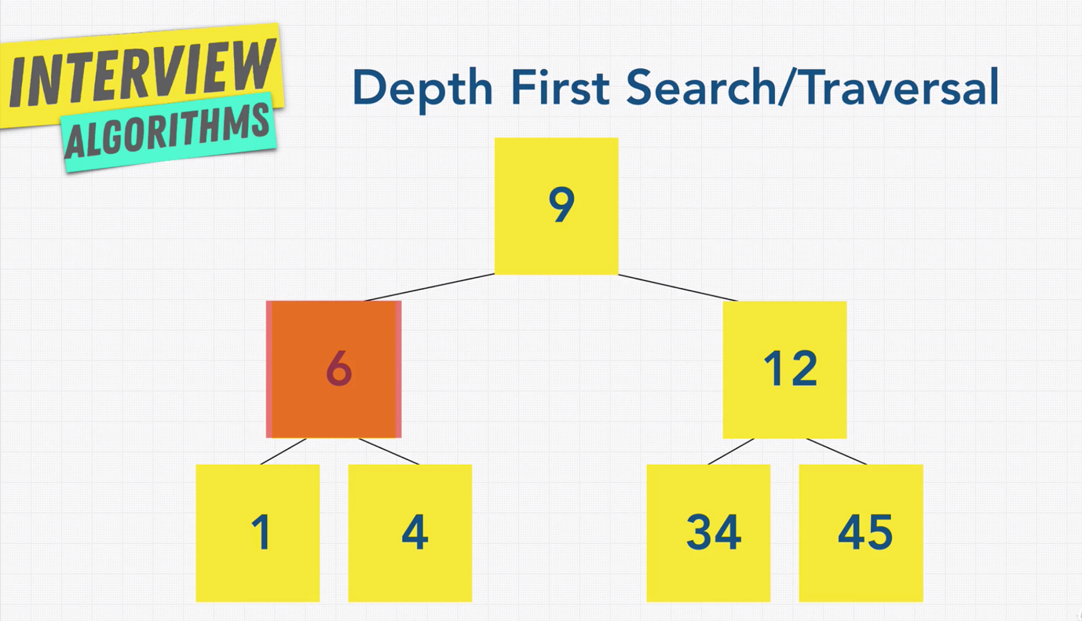

This traversal / search follows one branch of the tree down as many levels as possible until the target node is found or the end is reached.

When the search can go on any further, it continues at the nearest ancestor with unexplored child.

Example based on above tree.

Start with 9

Then go to 6 (left node), then 1. After one we reached a leaf

node.

Now go to the nearest ancestor which is 6, and check whether we have any unexplored child. We are left with 4, go there.

Now go to all the up 9, then do the same thing with the right node.

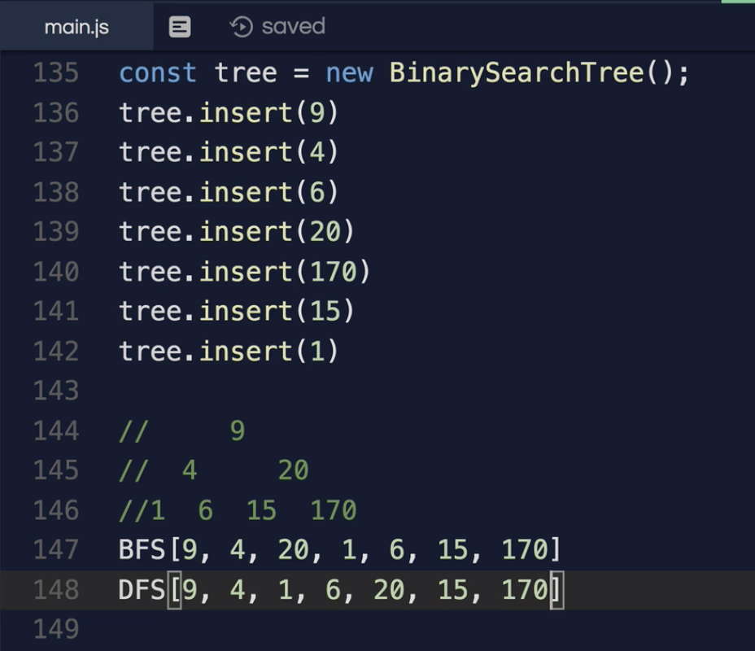

* **BFS vs DFS:**

BFS is like flooding from the water from top to bottom.



DFS is like shown below.

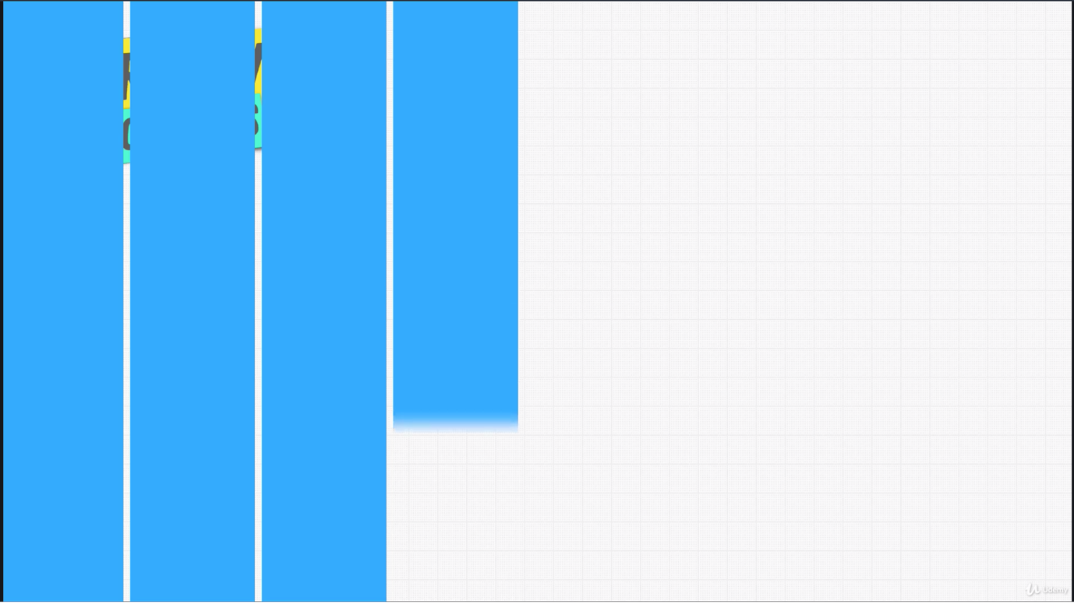

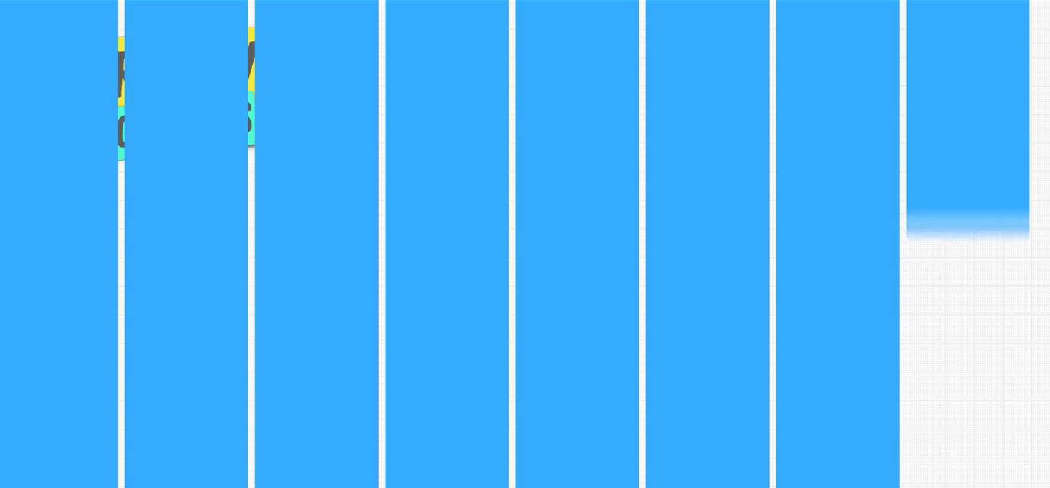

There are two different traversals / searches which one to use?

The time complexity for BFS and DFS is same O(n), as it has to visit each of the node.

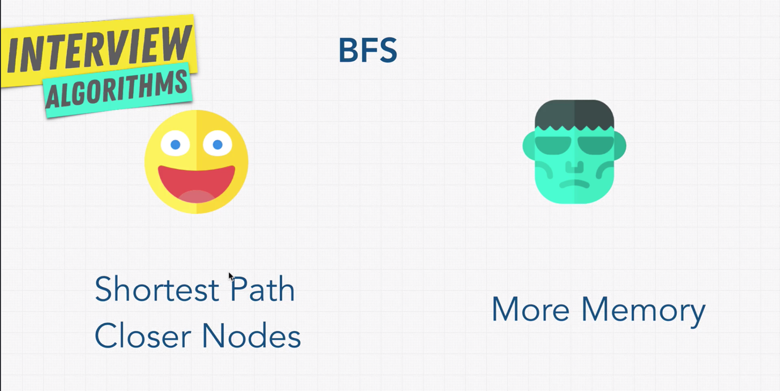

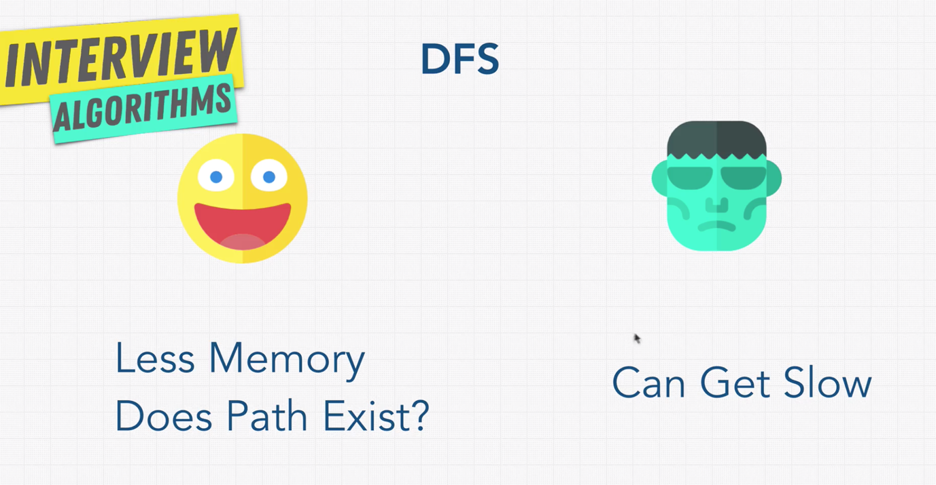

* **Exercise:**

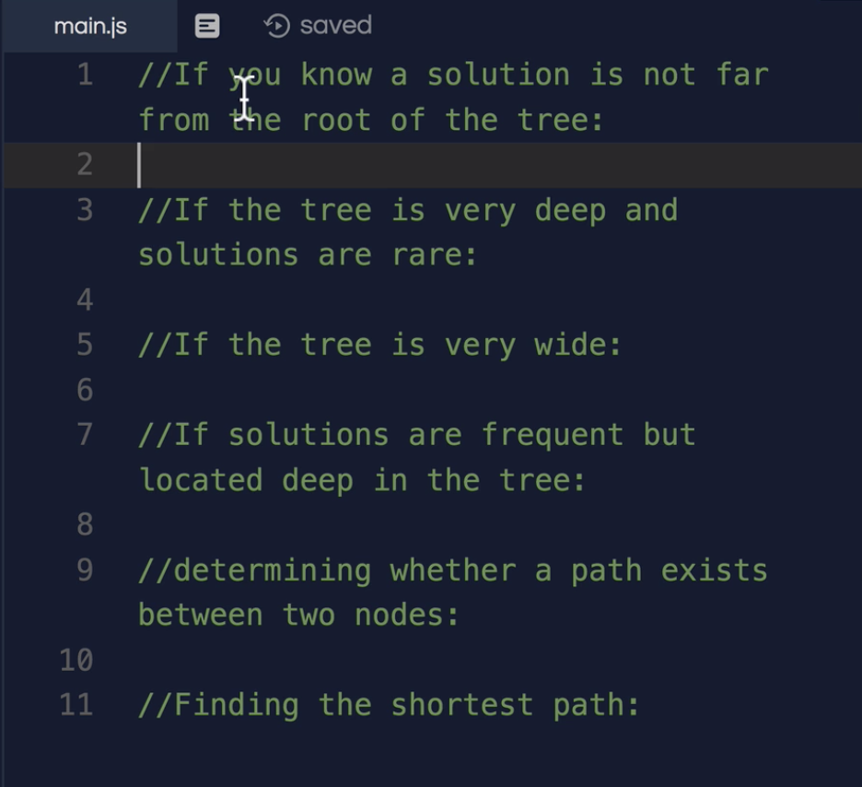

1 🡪 BFS

2 🡪 BFS (DFS will take long time).

3 🡪 DFS (BFS will need more memory).

4 🡪 DFS

5 🡪 DFS

6 🡪 BFS

